**Git FlowChart:**

**Adding project to git:**

## Adding a project to GitHub with GitHub CLI

1. In the command line, navigate to the root directory of your project.
2. Initialize the local directory as a Git repository.

git init -b main

1. To create a repository for your project on GitHub, use the gh repo create subcommand. Replace project-name with the desired name for your repository. If you want your project to belong to an organization instead of to your user account, specify the organization name and project name with organization-name/project-name.

gh repo create *project-name*

1. Pull changes from the new repository that you created. (If you created a .gitignore or LICENSE file in the previous step, this will pull those changes to your local directory.)

git pull --set-upstream origin main

1. Stage, commit, and push all of the files in your project.

git add . && git commit -m "initial commit" && git push

## Adding a project to GitHub without GitHub CLI

1. [Create a new repository](https://docs.github.com/en/articles/creating-a-new-repository) on GitHub.com. To avoid errors, do not initialize the new repository with *README*, license, or gitignore files. You can add these files after your project has been pushed to GitHub

.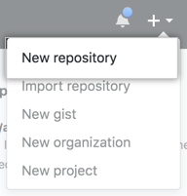

1. Open Git Bash.
2. Change the current working directory to your local project.
3. Initialize the local directory as a Git repository.

$ git init -b main

Add the files in your new local repository. This stages them for the first commit.

$ git add .

1. Commit the files that you've staged in your local repository.

$ git commit -m "First commit"

1. At the top of your repository on GitHub.com's Quick Setup page, click  to copy the remote repository URL.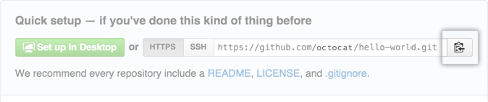
2. In the Command prompt, [add the URL for the remote repository](https://docs.github.com/en/github/getting-started-with-github/managing-remote-repositories) where your local repository will be pushed.
3. $ git remote add origin  *<REMOTE_URL>*
4. # Sets the new remote
5. $ git remote -v

# Verifies the new remote URL

1. [Push the changes](https://docs.github.com/en/github/getting-started-with-github/pushing-commits-to-a-remote-repository) in your local repository to GitHub.com.

$ git push origin main